July 9th, 2014

ChemTx Ltd.
9655 49th Ave
Edmonton, AB. Canada
T6E 5Z5

Attention: Allen Orr
VP Global Marketing

Dear Allen,

Thank you so much for introducing us to the Maintex chemical dilution system. On our site we have a diverse range of cleaning challenges ranging from agriculture, to food service, to office cleaning. Previously, to accommodate these challenges we have had to use a wide range of chemicals, but with your help we were able to reduce the variety of chemicals we were using down to 4. All of which are green certified.

A previous challenge with an eco friendly product line for us has been the cost and efficiency of chemicals. Thanks to the automated dilution system both of those issues have been addressed. Having the chemicals automatically diluted to the proper amount reduced the amount of product we were using helping to reduce costs. The cost savings were compounded by the fact that, comparing the price of diluted products litre to litre, your new products were cheaper than our previous ones. Reducing cost would be meaningless if the new products were not getting the job done, however, our cleaning results have met or exceeded what we were able to achieve with the variety of other chemical lines we were using before.

Not only was our staff grateful to have an easy to use, streamlined system of automatically diluted products, but our clients, who are very environmentally conscious, appreciated knowing that the chemicals used on their site were environmentally friendly and could aid them in pursuing LEED certification.

Thank you for your help, not only with product lines, but with always being there when we encounter a new and unusual cleaning challenge. Your knowledge and passion for this industry has been an invaluable asset to us.

Sincerely,

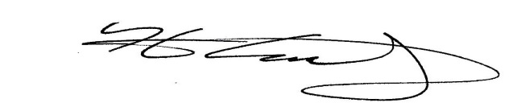
Kris Smolley
Site Manager - Bee Clean Building Maintenance

